INVITATION TO BID

FOR

THE PROVISION OF
MONITORING SYSTEM AND
ASSOCIATED SERVICES

(Bid No. : KNOC-GHD14-980-KOR)

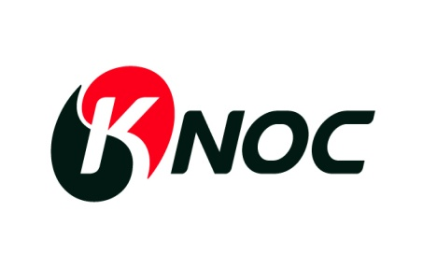

Korea National Oil Corporation

Table of Contents

BID ACKNOWLEDGMENT 3
1. Definitions 4
2. GENERAL INSTRUCTIONS TO BIDDERS 5
2.1 Estimated Schedule of Bid and Contracting Process 5
2.2 General Information and Instructions 5
2.3 Bid Validity 6
2.4 Cost of Bidding 6
2.5 Pricing 6
2.6 Bid Bond 6
2.7 Performance bond 7
3. BID PREPARATION PROCESS 8
3.1 Bid Package Contents 8
3.2 Clarification Of Bid Package 8
3.3 Amendment to The Bid Package by KNOC 8
4. BID SUBMISSION PROCESS 9
4.1 Submission of the Package 9
4.2 Bid Receiving and Opening 11
4.3 Bid Evaluation 11
5. AWARD OF BID 13
5.1 Notification of Award. 13
5.2 Condition of the Contract 13
EXHIBIT 1: WORK SCOPE & WELL INFORMATION 15
EXHIBIT 2: TECHNICAL SPECIFICATION 18
Exhibit 3 : SCHEDULE OF RATE 23
EXHIBIT 4 : PERSONNEL & OTHERS 26
EXHIBIT 5 : Form of MEMORANDUM OF REPLACEMENT 27
EXHIBIT 6 : PROFORMA OF PERFORMANCE BANK GUARANTEE 28
EXHIBIT 7 : COMMERCIAL PROPOSAL SUBMISSION 29

(Bidder’s Letterhead)

BID ACKNOWLEDGMENT

To: Korea National Oil Corporation
57, Gwanpyeong-ro 212 beon-gil
Donag-gu, Anyang-si, Gyeonggi-do,
Korea 431-711
Tel:
Fax:
E-mail :

Attention :
Bid No. : KNOC-GHD14-980-KOR
Bid Title : Invitation to bid for the provision of monitoring system and
associated services.

Dear Sir,
We acknowledge the receipt of the Bid Package for the above referenced Bid, and we agree to maintain total confidentiality in regard to the contents of the Bid Package.
We confirm (Check One Only)
Either: _______ We intend to submit a bona fide Bid by the Date and Time stated in your letter of Invitation to Bid.
Or: _______We do not intend to submit a Bid and hereby return the Bid Package disks.
Name of Bidder :
Signature :
Name (Printed) :
Position :
Date :
E-mail Address :
- Definitions

BIDDER A contractor who submits a Bid Package to be included in the KNOC required process to award a Contract.
Bid A binding offer by a BIDDER to enter into the Contract to provide Goods and Services. Any Bid must conform to the instructions contained herein.
Bid Submittal Forms Any KNOC generated forms and/or tables included in the Bid Package to assist in the presentation of the technical and commercial requirements of the Bid.
Bid Package A complete package of Bid Submission Forms and other documentation submitted by a BIDDER in accordance with these instructions.
Contract The specific terms, conditions, and requirements for the contracted relationship between KNOC and Contractor in performance of the Work.
Contractor Any person, firm, corporation, partnership or other business entity hired by KNOC to provide Goods and/or services under the Contract.
Goods All equipment, materials, spare parts, consumables, and any other physical objects to be provided under the terms and conditions of the Contract. Written reports fall into this definition.
Services The Work specified herein together with the other duties and obligations undertaken by the Contractor in accordance with the terms and conditions of the Contract, and any additional work or services carried out in connection therewith and the physical result of the performance of such duties and obligations.
Work The contracted technical result of the Contractor’s performance of the Contract. The Work is as defined in the Exhibit A
Job A specific piece of Work to be done in which the Contractor provides Goods and/or Services for KNOC.
HES Health Environment and Safety.

- GENERAL INSTRUCTIONS TO BIDDERS

  - Estimated Schedule of Bid and Contracting Process
Deadline for Bid Submission | 16th MAY 2014 (17:00)
Bid Evaluation | ~ 23rd MAY 2014
Approval and Award | ~30th MAY 2014

  - General Information and Instructions

    - Korea National Oil Corporation, (hereinafter referred to as “KNOC”) requires Goods as defined for its locations offshore Korea. Locations are as specified in the attached Draft Contract together with this Instruction to Bidders, Appendices and other relevant documents (“Bid Invitation Package”). Those suppliers that submit a response to the Bid Invitation Package (“BIDDER”) shall respond in accordance to the instructions within the Bid Invitation Package.
    - The Bid Invitation Package defines the basis of bidding for the Goods to be rendered by BIDDER. The Bid Invitation Package, with Appendices and Exhibits, if any, will be used by BIDDER in preparation of its proposals for submission to KNOC. Any selected BIDDER awarded the Contract shall perform the Work or provide goods in accordance with the terms and conditions of the Contract. BIDDER shall ensure a full understanding and knowledge of the Work and the prevailing terms and conditions under which the Work shall be performed. KNOC shall not be liable for any claims, in excess of the stated rates, sums and prices on account of conditions, costs or any other matters which could have been determined and understood at time of Bid submission.
    - BIDDER shall submit the Bid Acknowledgement document contained in these documents by either delivery or facsimile within three (5) working days after receipt of the Bid Invitation Package. All parties understand that the Bid Invitation Package is considered a confidential document between KNOC and Bidders.
    - Terms not otherwise defined in these Instructions to Bidders shall have the meaning set forth in the terms and conditions of the draft contract included with this package.
    - All Bidders must strictly comply with the instructions of this Invitation to Bid. BIDDER must not disregard the Bid Submittal Forms and refer to standard price lists or other pricing methods. BIDDER must calculate the actual rates and costs applicable to the Work. Failure to complete the Bid Package as per KNOC’s instructions in full, may lead to disqualification of the Bid. The completed Bid Submittal Forms, as submitted by the successful BIDDER, will be incorporated into the formal order or Contract.
    - All original Bid Package documents submitted shall be numbered and the cover letter signed as indicated by BIDDER or a person or persons authorized to sign on behalf of BIDDER
    - To assist in the examination and comparison of Bids, KNOC may, at its discretion, ask BIDDER for clarification of its Bid. BIDDER will respond to the clarification sought within the time stated in such a request, otherwise its Bid will be considered as off-specification. The request and the clarification shall be in writing via Fax or e-mail and no change in the price or substance of the Bid shall be sought or offered.
    - KNOC reserves the rights to accept or reject any and all Bids for any reason.
    - KNOC shall have the right to cancel the invitation to Bid process at any time, without prior consultation with any of the BIDDER and without costs to KNOC.
  - Bid Validity
The Bid shall be valid for Ninety (90) days from the date of submittal. If necessary, BIDDER may be asked by KNOC to extend their Bid validity and any associated cost shall be borne by BIDDER.
  - Cost of Bidding
BIDDER shall bear all costs associated with the preparation and submission of its Bid and KNOC shall in no case be responsible or liable for any of those costs, regardless of the conduct or outcome of the bidding process.
  - Pricing

    - Prices quoted should be your best possible prices. No negotiations on quoted prices will be permitted during the Bid evaluation process.
    - The Bid proposal prices should include all Goods and Services to be furnished by BIDDER and used in completion of the drilling operations by itself or any sub-contractor if BIDDER is awarded the Contract. Any licenses, fees, assessments, permits, or other charges incurred by BIDDER will be deemed to be included in the Bid proposal price, and will not be reimbursable as an additional amount by KNOC to BIDDER.
  - Bid Bond

The bidder should include in its bid proposal a Bank Guarantee in the form of a bid bond amounted to five (5) percent of the value of the agreement. The bid bond shall be issued by a bank in Korea or a reputable international bank acceptable to KNOC and shall be returned to the bidder after tender is accepted and awarded.
The bidder shall face forfeiture of the bid bond if:
    - the bidder withdraws its bid during its validity as specified in the General Instruction from KNOC or:
    - if the bidder refuses to sign the agreement in the event that the agreement is awarded to the bidder or:
    - if the bidder fails to or refuses to furnish the relative Performance Bond after the agreement has been signed.
Memorandum of Payment can be submitted as a substitute of Bid Bond.
(Form of Memorandum of Payment as per EXHIBIT 5)

  - Performance bond

    - The performance Bond
Contractor shall furnish to Company an irrevocable and unconditional performance bond from a first class international bank acceptable to Company, in form and content set out in EXHIBIT 6 within thirty (30) days of executing this Contract to secure the performance by Contractor of its obligations hereunder. The expiry date of the performance bond shall not be earlier than three (3) months after the end of the duration of this Contract or any extensions thereto, and its value shall be fifteen (15) percent of the estimated value of the total services to be provided, which as of the signing date of this Contract is agreed to be [insert amount]. The expense of preparing, completing and stamping such instrument shall be borne by Contractor
    - Expiry date of performance bond
Should the expiry date of the performance bond required to be furnished pursuant to the foregoing Article 2.7.1 be expected to occur before the termination of the Contract, Contractor shall at its expense, tender to Company at least fourteen (14) days before the date of expiry, a new performance bond in the form similar to and in the same amount of that previously provided, with a revised date of expiry which shall be not earlier than three (3) months after the expected termination date of this Contract.
    - Company’s right to withhold
If the performance bond to be furnished pursuant to clause 2.7.1 and 2.7.2 is not duly furnished by Contractor within the above prescribed period, Company may, without prejudice to any rights or claims it may have against Contractor by reason of Contractor noncompliance with any of the provisions of this Article, withhold an amount equivalent to the performance bond required from payment due to Contractor under this Contract until such time the performance bond is furnished by the Contractor whereupon Company will immediately release such sums withheld to Contractor. Company reserves the right to instruct Contractor to revise the amount of the performance bond to correspond to any increase in estimated value of total services.
    - Failure to perform
Should Contractor fail to furnish Company with the performance bond pursuant to clause 2.7.1 or any extension required under Article 2.7.2, Company may at its option and without prejudice to any rights or claims it may have against Contractor by reason of Contractor noncompliance with any of the provisions of this Article, terminate this Contract by notice in writing to Contractor. Company shall the thereupon not be liable for any claim or demand from Contractor.

- BID PREPARATION PROCESS

  - Bid Package Contents
BIDDER should have received the following documents:

Invitation to Bid including:
• Draft Contract for Wellhead Equipment and Services.
• Technical Specifications as per EXHIBITs.
• Commercial Specifications and Price Lists as per EXHIBITs.
• Other documents as per EXHIBITS

  - Clarification Of Bid Package

    - BIDDER shall examine all instructions, forms, and specifications in the Bid Invitation Package. If BIDDER is in doubt as to the meaning or interpretation of any part of the Bid Invitation Package, BIDDER should seek clarification in writing via Fax or email to KNOC. All questions and subsequent answers will be transmitted to all BIDDERs in writing via fax or email. Submission of a Bid by BIDDER shall mean that BIDDER has a clear understanding of the Bid Invitation Package.
    - Inquiries seeking clarification of the Invitation to Bid must be received in writing via Fax or e-mail no later than 13th MAY, 2014, 17:00 hours, Korea Standard Time, at the following address:
For Bid procedure :
∙ Attention : Yang, Geun-Myung / Assistant Manager, Procurement Team
∙ Telephone : +82-31-380-2366 (Fax : +82-31-387-9323)
∙ E-mail : geunmyung.yang@knoc.co.kr

For Technical information:
∙ Attention : Kim, Jaewoong / Assistant Manager, Drilling Dept.
∙ Telephone : +82-31-380-2964 (Fax : +82-31-384-7275)
∙ E-mail : jaewoong.kim@knoc.co.kr

  - Amendment to The Bid Package by KNOC

    - At any time prior to the deadline for submission of Bids, KNOC may, for any reason, whether at its own initiative or in response to a clarification requested by a BIDDER, modify the Bid Invitation Package by Amendment (“the Amendment”).
    - The Amendment shall be part of the Bid Invitation Package and BIDDER will be notified in writing via Fax or e-mail. All BIDDERs who have received the Bid Invitation Package will receive the Amendment and it shall be binding to them. BIDDER is required to acknowledge receipt of the Amendment in its Bid response.
    - In order to afford BIDDERs additional time in which to take the Amendment into account in preparing their Bid, KNOC may, at its discretion, extend the deadline for the submission of Bids.

- BID SUBMISSION PROCESS

  - Submission of the Package

    - Bid proposal shall be arrived at KNOC by 17:00 hours(Korean Standard Time), 16th MAY, 2014 and submitted by express mail service(EMS), courier or airmail only, however by fax or e-mail shall not be allowed.
    - Bid proposal must be addressed to KNOC as follows.
∙ Korea National Oil Corporation
∙ 57, Gwanpyeong-ro 212beon-gil, Dongan-gu, Anyang-si, Gyeonggi-do, Korea 431-711
∙ Telephone : +82-31-380-2366 (Fax : +82-31-387-9323)
∙ Attention : Yang, Geun-Myung / Assistant Manager, Procurement Team

    - BIDDER shall prepare separately sealed bid of technical proposal in one(1) original signed by BIDDER’s authorized officer and two(2) copies and CD/USB contained electric copy respectively, commercial proposal in one(1) original signed by BIDDER’s authorized officer.
    - Additionally, the following descriptions are duly marked on each envelope
1. Technical proposal or commercial proposal :
2. Bid Title :
3. Original or Copy :
4. Bidder’s Name :
5. Bid No. :

    - The bid proposals shall be prepared in accordance with the following terms and conditions
- All costs and expenses should be quoted in U.S. Dollar amount.
- All rates should be fixed for the duration of the Agreement.
- Contractor shall be responsible for income taxes when levied by any tax authority having jurisdiction to levy the taxes.
- Bidders shall be responsible for any expenses and/or losses incurred in preparation for his bid proposal

    - BIDDER should request a confirmation receipt from KNOC documenting when the Bid was received and who received it.
    - KNOC reserves the right to reject any or all proposals and any part of the bid proposal. On the part of KNOC, there is no commitment to accept the lowest bid or any bid and no accounting for unsuccessful BIDDERS.
    - The bid documents from the BIDDERS can’t be accepted any more after the bid closing date mention above.
    - Any change likewise any verbal or written explanations on the bid documents, which have been submitted, can’t be accepted.
    - The Bid Package should include the following information.
- Cover Letter
A letter signed by a duly authorized representative of BIDDER, introducing the Bid and clarifying the name, address and country of incorporation of the actual corporate identity to which the Contract would be awarded.
- Technical Specifications of Goods, Equipment, Services, and Personnel
This Technical proposal should contain sufficient information to allow KNOC to make a fair assessment of BIDDER’s understanding of all the work scope and capability to carry out the project in an effective manner.
BIDDER should submit edited electronic copy of EXHIBIT 2 and EXHIBIT 4 in this proposal. Electronic copies of these Exhibits are provided for easier editing. Exceptions and Alternatives to these Exhibits should also be listed if any.
BIDDER may present exceptions or alternatives to these required technical specifications that add value, but these must be documented in the response.
BIDDER’s exceptions or alternatives should exceed requirement, potentially provide better value to KNOC.
This Technical Proposal should contain the followings;
- KNOC Bid Form.
- Exhibit “2” TECHNICAL SPECIFICATION & Technical support documents such as running procedures, tools guidelines
- The resume of the personnel proposed by BIDDER including age, nationality, educational background and experience in Exhibit “4” PERSONNEL & OTHERS
- BIDDER’s company profile.
- BIDDER’s Organization Chart depicting the proposed organization in the region to perform the work (List of key personnel by name, if known, Contact Number and Job Descriptions.) .
- A copy of certificate of incorporation to prove which country BIDDER’s company is registered in.
- BIDDER’s working experience history for last 3 years.
- BIDDER’s annual program of HSE, the emergency response

- Sub-contractors
In case BIDDER proposes to sub-contract any portion of the Services, BIDDER shall explain fully the nature and extent of such Services of the sub-contractor.
The sub-contractor(s) can only be engaged on written approval of KNOC.
- Commercial Response – Price List and Commercial Terms
BIDDER will provide responses to the commercial terms and complete the price list templates as required.
BIDDER may present options or variations to these required commercial specifications that add value, but these must be documented separately in this response. Options may include alternatives known to BIDDER that exceed requirements, potentially providing better value to KNOC.
This Commercial Proposal should contain the followings;
- KNOC Bid Form.
- Exhibit “3” SCHEDULE OF RATE.
- Exhibit “5” MEMORANDUM OF PAYMENT or Bid Bond
- Exhibit “7” COMMERCIAL PROPOSAL SUBMISSION

- Exceptions to Draft Agreement
BIDDER shall summarize all exceptions taken in the Invitation to Bid. BIDDER should list its enhancements first, followed by its exceptions. Alternative wording to the draft contract should be listed here for consideration.
  - Bid Evaluation
KNOC shall conduct an evaluation on all bids submitted. The factors quoted in the bid proposals shall be qualified in accordance with those required in the bid invitation document and its appendices. KNOC is not allowed to add or reduce the factors required in bid invitation document after receiving the bid proposal from the BIDDERS.
The BIDDER that submitted all required documents can be considered for technical evaluation.
The evaluation of this Bid will be using pass and fail system and based on the following selection criteria.
Evaluation Items
Monitoring System | Provide Subsea pressure & temperature measurement system which meets technical minimum requirements
Monitoring System | Provide Acoustic Data Transmission system
Monitoring System | Provide sufficient test plans to guarantee the system integrity and qualification
Rental Tools and Services | Engineers w/ 5 year experiences or more
Rental Tools and Services | Supply rental tools for installation of monitoring system
Delivery | By 31st Mar, 2015 in Busan
Result (Pass / Fail)
.
    - Technical Proposal
Technical Proposal shall be opened and evaluated first after the time of bid closing date for Technical Proposal specified in the Invitation to Bid.
- The most important factor of evaluation is delivery time and specifications of the equipment. KNOC may disqualify a bidder who cannot meet the required delivery time and specifications.
- The Bids will be reviewed from the perspectives of engineering design, running efficiency, material quality, technical merit, perceived product and service quality and the overall general track record of the BIDDER.
- KNOC will only seek additional information for those technical specifications that need clarification, following the opening of the Technical Proposals.

4.3.2 Commercial Proposal
Evaluation of the Commercial Proposal will only be conducted on those bidders whos Technical proposal was fully qualified with “Pass” in all evaluation items by KNOC through the evaluation of the technical proposal.
KNOC will select BIDDER that has submitted the lowest priced proposal(“evaluated”price) among those that passed the technical evaluation
4.3.3 Negotiation
Upon determination of the selected BIDDER, negotiations will be held with an aim to reach agreement on all aspects of the assignment.

If negotiations fail, for whatever reasons or the outcome of such negotiations are not satisfactory, at the sole discretion of KNOC, KNOC will invite the BIDDER that submitted the next lowest priced bidder to negotiate a contract.
The contract will be awarded subject to (i) successful negotiations of the contract, (ii) approval of contract award by KNOC's contract awarding authority.

Unsuccessful BIDDERs will be promptly advised once the bid process has been finalized. The KNOC is not obligated to give any explanations to unsuccessful benders as to the reason or reasons why their bid proposal was not selected.

    - Letter of Intent

After evaluation of the Commercial Proposal, KNOC may issue the Letter Of Intent to choose a candidate of successful BIDDER.

- AWARD OF BID

  - Notification of Award.
After bid evaluation, KNOC will award the contract to the successful BIDDER whose bid has been determined to be substantially responsive and qualified to perform the contract.
  - Condition of the Contract
Any Contract signed as a result of this Invitation to Bid will be governed by the terms and conditions of the Contract. BIDDER must include in its Bid a statement confirming "In the event of a Contract being placed with BIDDER, BIDDER will accept the said conditions."

KNOC BID FORM

Bid No. : KNOC-GHD14-980-KOR
Subject : Provision of Monitoring system and associated services

Bid Closing Date : 16th MAY 2014, 17:00 hours, KOREA Time

In compliance with instructions of the invitation to bid, requirements thereof and general provisions of the contract rendered by KNOC, and aware of all the working conditions including, but not limited to, manpower, immigrations, taxes, custom regulations and applicable laws hereto,

The undersigned duly offers and agrees, if this bid accepted by KNOC to furnish to KNOC any services under this invitation to bid upon the price and fees as quoted formally herein.

NAME AND ADDRESS :

SEAL AND SIGNATURE :

EXHIBIT 1: WORK SCOPE & WELL INFORMATION

- CONTRACTOR shall perform the Work as set out in the CONTRACT. The Work includes the following services.

- Provide pressure & temperature measurement system and field services for two (2) monitoring wells.
- Conduct all required lab tests and SIT(System Integrity Test) for guaranteeing qualification and integration of the system.
- Anticipated delivery date is March 31st, 2015 and the confirmation of the delivery date will be specified on the delivery order by COMPANY.
- Anticipated spud date is early April, 2015.
- CONTRACTOR Personnel shall inspect all equipment in COMPANY’s Busan supply base in Korea at least two weeks prior to the anticipated spud date.
- Furnish transportation from CONTRACTOR’s point of origin of materials to KNOC’s logistics base in Busan, Korea.
- Supply capable, competent and reliable service personnel on a call-out basis to manage all aspects of the monitoring system handling, running, retrieving and troubleshooting operations.
- Provide reports of any job successes, failures and difficulties.
- CONTRACTOR shall provide all necessary importation documentation to COMPANY.
- CONTRACTOR is requested to give quotes for:
  - Monitoring System
  - Rental Equipment for installation
  - Lab Test, QC, SIT(System Integrity Test)
  - Service Hands

- Drilling Program

- Number of wells : One(1) production well and Two monitoring wells, only monitoring wells are in the workscope for this monitoring system.
- Location : East Sea Offshore Korea
- Expected Spud date: Early of April, 2015
- Expected Operation period: 50 ~ 66 days
- Water Depth : Approx 2160m
- Maximum well depth: 155 ~ 180m TVD from seabed
- Rig : Ultra Deepwater Drillship (TBD)

- Well and Monitoring Plan

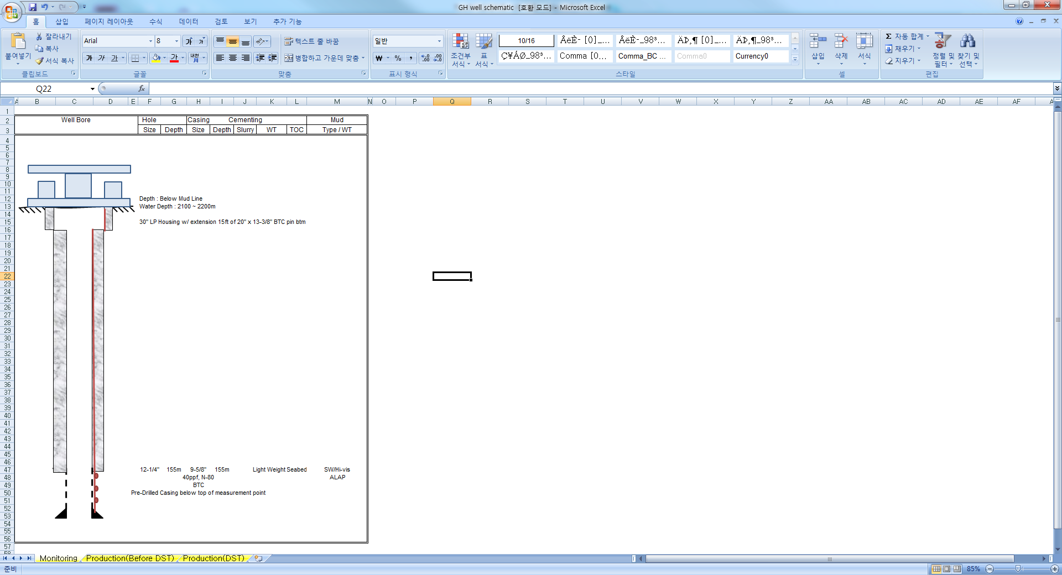

< Monitoring Well >
Hole | Depth  (TVD,BML) | CSG | Formation Pressure (ppg) | Mud  Density (ppg)
12-1/4” | 160m | 9-5/8” | TBA | SW
* Subject to change as per final Drilling Program

This monitoring well is drilled w/ only 12-1/4” hole to approx. 160m below seabed TD. 30” wellhead is swaged to 20” directly within the housing and the next is X/O to 9-5/8”. Below this 9-5/8” casing will be set and cemented to TD. Gas Hydrate bearing interval is around 138 to 153m below seabed and the interval will not be cemented. The temperature and pressure gauges installed in the interval mainly. Well in planned to be suspended.

<General lay out of the monitoring system>
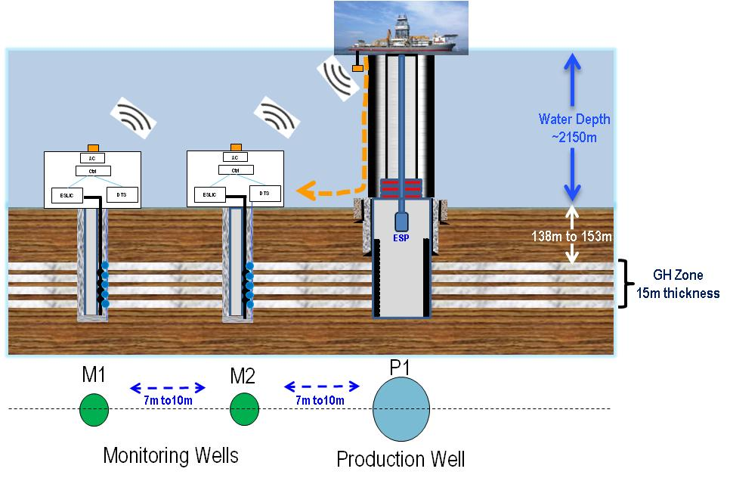

There will be two(2) cables for pressure gauges and temperature gauges respectively and the cables are attached to casing outside w/ clamps to avoid any damage during RIH as below. The measured data will be stored in memory on seabed (USB type preferred) and after finishing all operation the memory will be recovered by ROV. During the operation full or partial data should be sent to surface by Acoustic Data Transmitter.
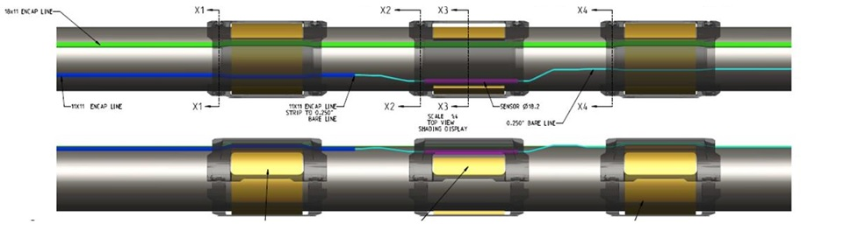

EXHIBIT 2: TECHNICAL SPECIFICATION

- MINIMUM SPECIFICATION

 | Minimum Requirement
Pressure | - Pressure working range : 0 psi ~ 3500psi  - Accuracy : +/- 2 psi  - Resolution : 0.5 psi
Temperature | - Temp. Range : -10 deg c ~ 50 deg c  - Accuracy : +/- 0.1 deg c  - Resolution : 0.01 deg c
Seabed System | - Working in 2200m water depth (3400 psi and 0 dec C)  - Proven acoustic data transmission for measured data  - Full data memory retrieved by ROV after operation  - Battery lasting for 4 months in 2200m water w/ system
Surface system | Working on the conventional ultra deepwater drillship
Lab Test and SIT test | Required proficiency on the engineering and plans for integrity and quality of the whole system
Lead Time | Whole system arrival in Busan, Korea by March 31st 2015

- MONITORING SYSTEM

* Specify all the detail for proposed system.
* Provide w/ all the equipment specification, field history, deployment of system and recovery of memory procedure and system drawings w/ dimensions.
 | Company Requirements | Contractor’s Specifications
General equipment | clamps  - For fixing cables onto casing  - Include the others if recommendable to mitigate cable damage during RIH  - No movement of clamps while RIH casing
General equipment | PRESSURE VESSEL  - Contains all seabed systems and provide pressure sealing
General equipment | MECHANICAL PARTS  - Whole sets of frame, ROV panel and the other parts to secure the pressure vessel and subsea memory system on the mudmat
General equipment | SUBSEA MEMORY SYSTEM  - USB type preferred  - Recoverable by ROV  - Memorize all data from gauges on seabed
General equipment | SUBSEA BATTERY  - Last approx 4 months with deepwater environment (0 deg C, 3500psi) operating whole system
General equipment | ACOUSTIC SURFACE SYSTEM  - To receive all acoustic data from seabed  - Installed around moonpool area  - Working on normal drillship noise
PRESSURE GAUGE SYSTEM | PRESSURE GAUGE SYSTEM  - Meets minimum requirements  - Multidrop Pressure Gauge 7 ea per well (1 cable)  - Single Pressure Gauge 1 ea per well (1 cable)  - Including 250m cable per well  - Including subsea controller per well for pressure data handling  - Including 1 ea splicing chamber per well for cable damage recovery on rig  - Including 1 acoustic module per well to send pressure data to surface  - Including 1 surface acquisition unit for surface test
TEMP.  GAUGE SYSTEM | TEMPERATURE GAUGE SYSTEM  - Meets minimum requirements  - Temperature Gauge 15 ea per well (1 cable)  - Including 250m cable per well  - Including subsea controller per well for temp data handling  - Including 1 ea splicing chamber per well for cable damage recovery on rig  - Including 1 acoustic module per well to send temperature data to surface  - Including 1 surface acquisition unit for surface test
Lab Tests, QC, System Integration Test | TESTS  - Specify all the test plan detail for guaranteeing qualification and integrity of your system. KNOC will evaluate the plans  - Including test facilities and equipment rental  - Including engineers and engineering charges for testing and detailed design  - Including shipping, storage, customs and duties during the tests and final assembly. These costs shall be included in lump sum base
OTHERS | OTHERS  - Any others recommendable

- FIELD SERVICE

Company Requirements | Contractor’s Specifications
REnTAL TOOLS
- Rental tools for installation the monitoring system such as spoolers, surface data acquisition unit, cabin, shipping frame and spares
- Specify all the rental or consumable items which are not included in the purchased monitoring system

ENGINEERS
- Field service engineers for installation on moonpool and for data acquisition
- Specify no of engineers required for your system.

- TEST PLANS

All the detailed test plans will be determined after contract but at least the list of the tests shall be decided during tender process. Specify the plans for lab tests item by item such as but not limited to acoustic system evaluation test, sensor cable fitting test /w clamp, pressure housing sealing test and the test for qualifying gauges.
Specify the plans for SIT(System Integration Test) w/ final assembly before shipping to KNOC such as but not limited to communication check, sensor function check, data upload/download and battery life check.

- LEAD TIME FOR MONITORING SYSTEMS
.
____________ Weeks after receipt of order by COMPANY including shipping time to Pusan Port, Korea.

Exhibit 3: SCHEDULE OF RATE

MONITORING SYSTEM
ITEM | PURCHASE PRICE(US$/EA)
CLAMPS
Quantity : 100 ea
PRESSURE VESSEL
Quantity : 2 ea
MECHANICAL PARTS
Quantity : 2 Set
SUBSEA MEMORY SYSTEM
Quantity : 2 Set
SUBSEA BATTERY
Quantity : 2 Set
* Specify additional battery cost and duration per battery
ACOUSTIC SURFACE SYSTEM
Quantity : 1 Set
PRESSURE GAUGE SYSTEM  Quantity : 2 Set | * Specify price of each item.  * Specify the others not mentioned on the technical specification for your system.
TEMPERATURE GAUGE SYSTEM  Quantity : 2 Set | * Specify price of each item.  * Specify the others not mentioned on the technical specification for your system.
TESTS
Lump sum
Others if recommendable
Sub Total

- Above prices are CIF prices to COMPANY’s supply base in Korea and exclusive of all the customs and taxes in Korea.
- Number of equipment is subject to COMPANY’s drilling program.

RENTAL TOOLS

- Rental charge
- Rental tools (Including back up) : US$ /Day/Lumpsum
* Anticipated days for rental : 103 days (for caculation of total contract price)

- Mob/Demob charge for Rental equipment
- Mob charge : US$ /Lump sum
- Demob charge : US$ /Lump sum

3. LIH Value
ITEM | LIH  (US$/EA) | QUANTITY

- All tAll the rental tools for monitoring system for production test & monitoring wells shall be listed respectively above w/ LIH values and quantities.

PERSONNEL

Minimum 5 year experienced operator(s) are required to run this equipment. The engineers shall cover 24 hours on the rig.
* Anticipated days for personnel : 84 days (for caculation of total contract price)

1. Daily Personnel Rate : US$ /Man/Day
2. Accommodation : US$ /Man/Day
3. Lump Sum Mob/De-mob Charges : US$ /Man/Trip

NOTE :
1. Summary of Rate
ITEM |  | PURCHASE PRICE(lump sum)
MONITORING SYSTEM | CLAMPS  Quantity : 100 ea
MONITORING SYSTEM | PRESSURE VESSEL  Quantity : 2 ea
MONITORING SYSTEM | MECHANICAL PARTS  Quantity : 2 Set
MONITORING SYSTEM | SUBSEA MEMORY SYSTEM  Quantity : 2 Set
MONITORING SYSTEM | SUBSEA BATTERY  Quantity : 2 Set
MONITORING SYSTEM | * Specify additional battery cost and duration per battery
MONITORING SYSTEM | ACOUSTIC SURFACE SYSTEM  Quantity : 1 Set
MONITORING SYSTEM | PRESSURE GAUGE SYSTEM  Quantity : 2 Set
MONITORING SYSTEM | TEMPERATURE GAUGE SYSTEM  Quantity : 2 Set
MONITORING SYSTEM | TESTS  Lump sum
MONITORING SYSTEM | Others if recommendable
MONITORING SYSTEM | Sub Total
RENTAL TOOLS  * For 103 days  * For all tools | Rental charge
RENTAL TOOLS  * For 103 days  * For all tools | Mob/Demob charge
RENTAL TOOLS  * For 103 days  * For all tools | Sub Total
PERSONNEL  * For 84 days  * For all Engineers | Personnel Rate
PERSONNEL  * For 84 days  * For all Engineers | Accommodation
PERSONNEL  * For 84 days  * For all Engineers | Mob/De-mob Charges
PERSONNEL  * For 84 days  * For all Engineers | Sub Total
Grand Total

2. The delivery time of whole system at COMPANY’s supply base, in Busan, Korea is no later than March 31st 2015.

3. CONTRACTOR shall guarantee that at the time of delivery, all equipment shall be free from any defects and full set of inspection certificates for the equipment shall be submitted.

4. Daily Personnel Rate will be commenced upon the date of arrival of the engineer in Korea at COMPANY’s request and cease upon the date of his departure from Korea.

5. Engineer Mob/Demob shall be charged in lump sum and include day rate during mob/demob, airfare, accommodation, work permit, visa, transportation and other expenses.

6. Accommodation means all relevant costs for each engineer rotation like hotel, food, transportation and others when he stays overnight in onshore Korea. Accommodation will be applied only while daily personnel rate is applied. Relevant supporting documents shall be submitted.

7. COMPANY shall provide transportation for equipment and personnel between COMPANY's supply base and the rig. CONTRACTOR shall be responsible for transportation of the equipment and personnel from Mobilization Point to COMPANY's Busan supply base and from COMPANY's supply base to Demobilization Point.

8. Rental charges will commence from the date all equipment is arrived in Busan Port, Korea by COMPANY’s request and cease on the date when the same departs from Busan Port, Korea.

9. COMPANY will provide food and accommodation for CONTRACTOR’s personnel on the Rig.

10. The CONTRACTOR shall assign Service Engineers on a Call-Out Basis at any time upon the COMPANY’s five(5) days or less prior notice to carry out field services for the COMPANY’s drilling operations

11. There will be wellhead dry stack up test before shipping to Korea. For the test, CONTRACTOR shall supply engineers, pressure vessel, frame, sample cables and others required to test the interface between wellhead and monitoring system. All the relevant costs shall be included in the lump sum of TESTS.

12. Shift schedule(If necessary) : 28 days on/off

EXHIBIT 4 : PERSONNEL & OTHERS

1. PERSONNEL

The personnel provided for this Agreement shall consist of :
Position | Name | Nationality | Experience(Years)
Note 1: Resume of personnel shall be attached.

2. Contractor Information

In country office/operations base | :
Contract Name | :
Phone Number | :
24 hour phone number | :
Notices | :
Payments information

EXHIBIT 5 : Form of MEMORANDUM OF PAYMENT

Date: [Bidder to insert date]

To: Korea National Oil Corporation

Ladies/Gentlemen:

In compliance with Act On The Contracts To Which The State Is A Party (Contract Act Of Korea), the bidder hereby furnish this memorandum of payment as a substitute for the bid bond to protect KNOC against the risk of the bidder’s conduct, which would warrant the bid bond’s forfeiture, pursuant to the bidding documents(Bid No. KNOC-GHD14-980-KOR).

We agree to pay you in an amount equal to five (5) percent of the total price(US$:___) specified as commercial proposal by the bidder, in the event that the following are made;
a) If we withdraw our bid during its validity as specified in this ITB from COMPANY or,
b) If we refuse to sign the contract in the event that the contract is awarded to us or
c) In case we fail to or refuses to furnish the relative performance bond after the contract has been signed.

Yours sincerely,

Authorized Signature:

Name and Title of Signatory:

Name of Firm:

Address:

Date:

EXHIBIT 6 : PROFORMA OF PERFORMANCE BANK GUARANTEE

[Bank letterhead]

To: KOREA NATIONAL OIL CORPORATION
57, Gwanpyeong-ro 212 beon-gil
Donag-gu, Anyang-si, Gyeonggi-do,
Korea 431-711
Tel: 82-31-380-2366
Fax: 82-31-387-9323

Date:

Whereas you concluded a Contract for the provision of wellhead with associated services dated ____________ with [Contractor] (hereinafter referred to as "Contractor") in Offshore, Korea (hereinafter called the "the Contract"); and

Whereas the Contract provides that Contractor shall furnish a performance bond for US$______;

Now therefore at the request of and for the account of Contractor, we ______________ Bank, irrevocably and unconditionally undertake to pay you any amount up to a maximum amount of

US$ _____.

without delay on your first written demand for payment presented at our branch located at ____________________ stating that the Contractor is in breach of the Contract. Our obligations hereunder shall not be diminished or otherwise affected by any alteration, modification or amendment of the Contract.

This Performance Bond is valid from the date hereof until three (3) months after the end of the duration of this Contract.

This Performance Bond shall be governed by and interpreted in accordance with the laws of Republic of Korea, without reference to conflicts of laws principles that would apply the laws of any other jurisdiction and we hereby submit to the exclusive jurisdiction of the courts in Korea. For this purpose, our address for service of any notice, demand, proceeding, etc., shall be at _________________________________ and such address shall be subject to change only with prior consent of the Company.

Upon its expiration, this Performance Bond shall be returned to us.

BANK

EXHIBIT 7 : COMMERCIAL PROPOSAL SUBMISSION

Date: [Bidder to insert date]

To: Korea National Oil Corporation

Ladies/Gentlemen:

We, the undersigned, offer to provide the services in accordance with your request for ITB (Bid No. KNOC-GHD14-980-KOR) and our proposal consisting of the technical and commercial proposals.

Our attached commercial proposal is for the sum(USD) of [Bidder to insert amount in words and figures] excluding VAT.

Our commercial proposal shall be binding upon us subject to the modifications resulting from contract negotiations, up to expiration of the validity period of the proposal, i.e. within sixty (60) calendar days from the closing date of bid proposals.

We understand you are not bound to accept any proposal you receive.

Yours sincerely,

Authorized Signature:

Name and Title of Signatory:

Name of Firm:

Address:

Date:

